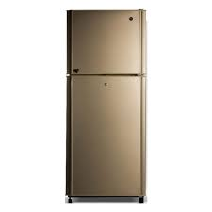

PEL PRL2150

* Type Top Freezer
* Capacity 8 Cu Ft
* Color Grey
* Dimensions 615x1425 X665
* **Rs.44,913**